Revision Questions: Criterion A - MYP4 Year Test

Level 1-2:

- Friction is always in the ___ direction motion force
  - opposite
  - same
  - perpendicular
  - parallel

- ATP is…
  - An energy storage
  - Consumed during cellular respiration
  - Only found in plant cells
  - An acid

- Fill in the blanks:
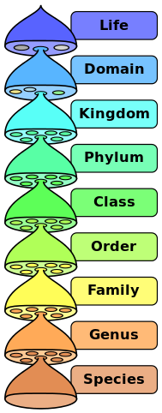

- State the four fundamental forces of physics

- Connect the fundamental forces with their correct force carrying particles

Gravitational Force Photon

Electromagnetic Force Gluon

Strong Force Graviton

Weak Force W/Z bosons

- State the quarks in a proton

- Select the correct name for the following covalent compound: CCl₄
  - Carbon dichloride
  - Carbon tetrachloride
  - Dichlorine carbide
  - Tetrachlorine carbide

- A model of a spacecraft is built using a scale of 1:100. If the actual spacecraft is 30 meters long, how long is the model?
  - 0.3 m
  - 3 m
  - 0.03 m
  - 300 m

- Looking at the periodic table, select the element with the highest electronegativity out of these options:
  - Sodium
  - Nitrogen
  - Boron
  - Chlorine

- Going to the right within a period in the periodic table, the atomic radius…
  - Increases
  - Decreases
  - Stays constant
  - First decreases, then increases again

Level 3-4:

- Differentiate between Temperature and Heat.

- Calculate the heat energy it takes to raise the temperature of 524g of lead by 56K. The specific heat capacity of lead is 128J/kg/K

- Using the following dichotomous key, determine which class of vertebrate the animal on the photo belongs to:
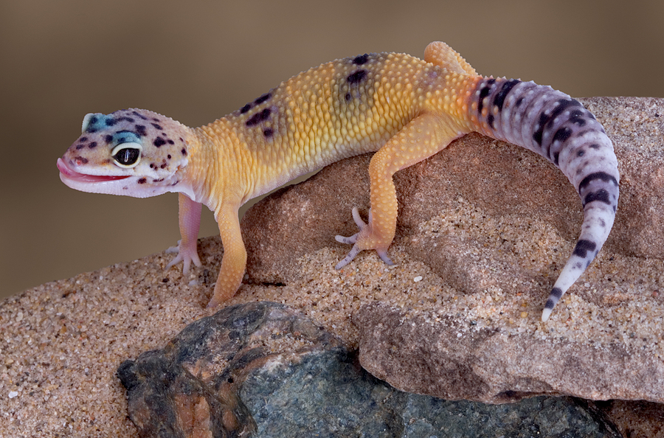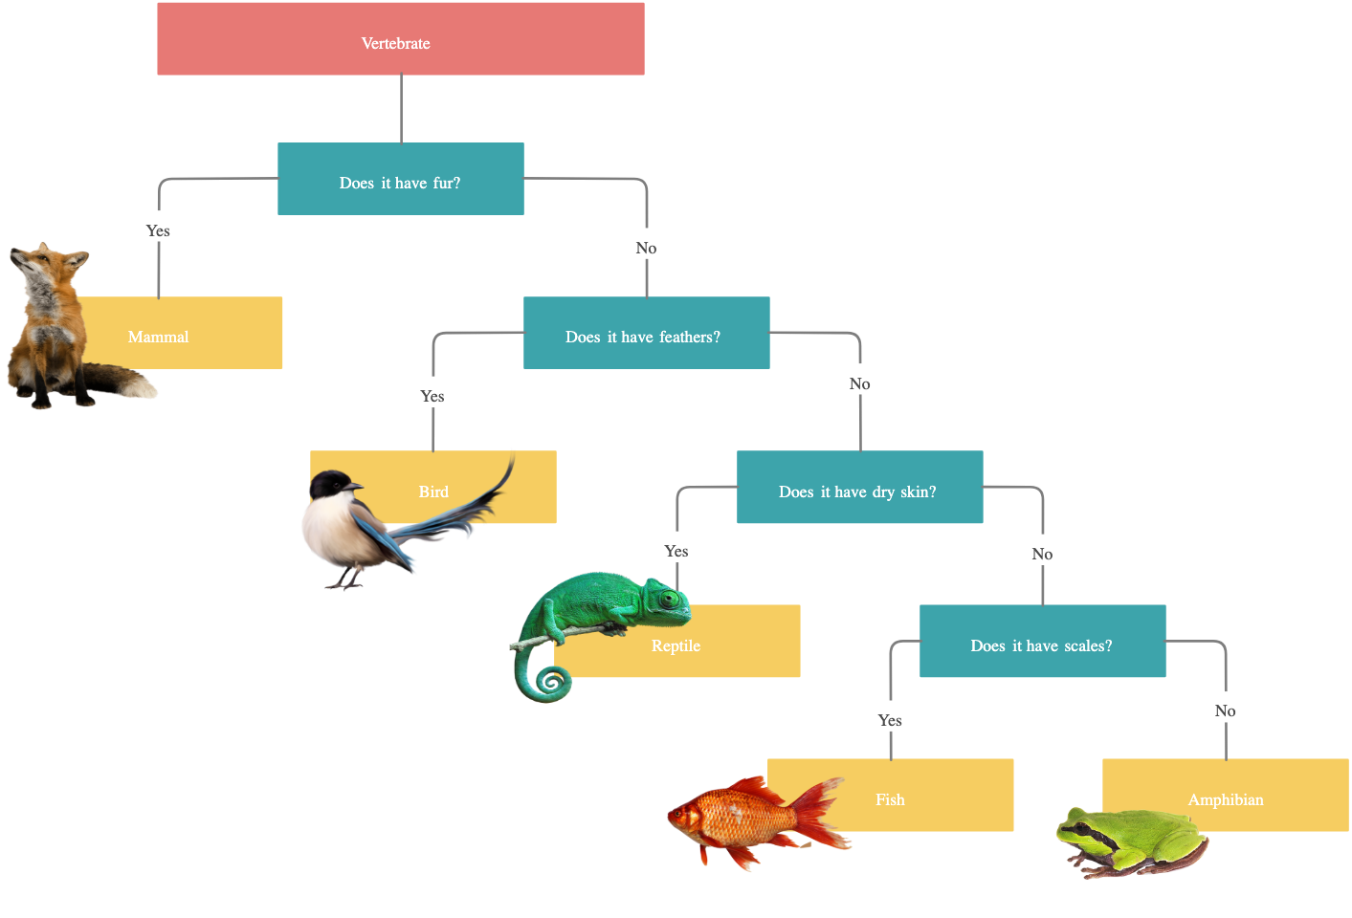
- Describe the purpose of a dichotomous key

- Calculate the effective nuclear charge acting on the valence electron of a sodium (Na) atom.

- Define the term “electron shell”.

- Draw the electron configuration of a sulfur atom

- Calculate the amount of moles of copper in a 30g bar of copper.

- Outline the difference between mass and weight

- Define the term “ion”

- List the physical properties of substances with a metallic bonding structure

- Giving a named example of each, outline the differences between an anion and a cation.

- Calculate the net force acting on the rope in the following situation:
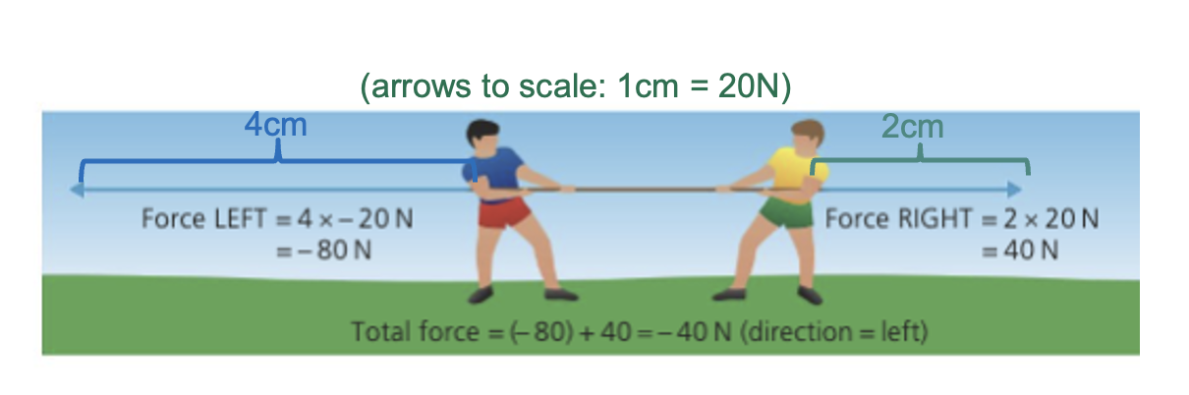
- Compare gravitational force and strong force in terms of their relative strength and range.

- How much heat energy does it take to heat 50.0 g of water from 25.0 °C to 75.0 °C? (Specific heat capacity of water = 4182 J/kg/°C)

Level 5-6:

- Draw a diagram showing the heat transfer from a glass of warm water into the hand of the person holding it, on the particle level.

- Compare and contrast latent and sensible heat

- Describe the graph below:

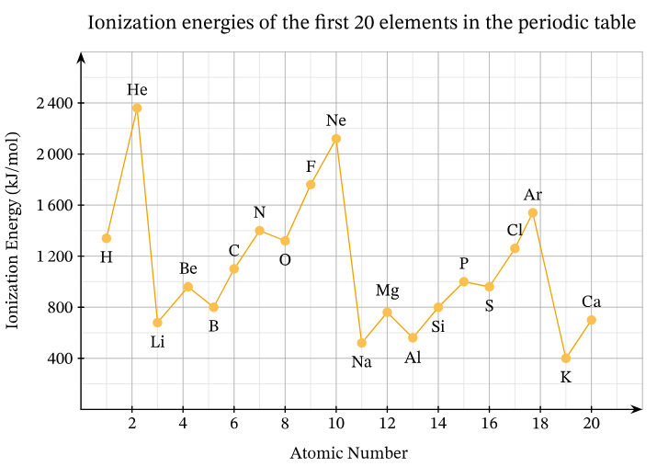

- At their closest point in their orbits, Pluto and Neptune are 360.000.000km apart from each other. Neptune’s mass is 1.024×10²⁶ kg. Pluto’s mass is 1.309×10²² kg. Calculate the gravitational pull between the two planets!

- Describe the change in properties of a fluorine (F) atom, if a proton was added to its nucleus

- Beryllium and Oxygen can react to form an ionic compound. Draw the electron shell diagrams of Beryllium and Oxygen, and indicate with arrows the movement of electrons during the reaction

- Describe the differences in chemical properties between metals and non-metals using examples from the periodic table.

- Describe the link between the position of an element in the periodic table and its atomic number and electron configuration.

- State the charges of the ions formed by Aluminium and oxygen. Then deduce the chemical formula of the ionic compound formed between aluminium and oxygen.

- Using a dot-and-cross diagram, show the movement of electrons during the formation of the ionic compound Magnesium oxide (MgO) from magnesium and oxygen atoms.

- Draw and label a diagram showing the brittle nature of an ionic compound at the particle level.

- Draw a dot-and-cross diagram showing the bonding in methane (CH₄)
Level 7-8:

- Draw and label the heating curve of water. Label the regions of the diagram in which latent and sensible heat are exchange

- Your friend studying photosynthesis is making the following claim: “Even during the dark, plants can still produce glucose through photosynthesis”. Evaluate to what extent that statement is correct!

- Your friend claims to have observed a strong reaction between the elements Lithium and Calcium. Determine whether your friend is lying, and justify your response.

- Explain why the reactivity of non-metals increases going higher up in a group, while the metallic reactivity decreases going higher up in a group.

- Explain how the schematic of a campfire relates to the scientific concept of electron shielding

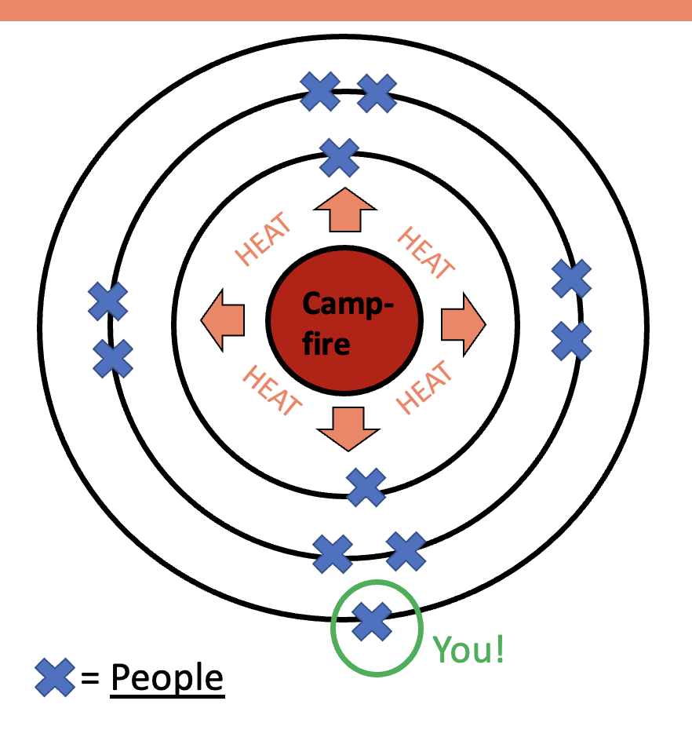

- Explain why the atomic mass of an element on the periodic table is not always an integer (a whole number).

- The gravitational force between two objects that are 2.1 x 10⁻¹m apart is 3.2 x 10⁻⁶N. If the mass of one object is 55 kg, calculate the mass of the other object.

- Justify why it is necessary to have roman numerals in the name of FeCl₃ (iron(III) chloride), but not in the name of NaCl (Sodium chloride).

- Evaluate to what extent the properties of ionic compounds make them more suitable building materials for construction than other type of chemical compounds.

- In the year 2100, a spaceship is exploring the nearest star to our solar system, Proxima Centauri. When approaching the star, the spaceship is struck by an asteroid that knocks it off course and destroys the navigation system and engines of the ship. The crew is now worried that the ship is too close to the star, and might be pulled in by its gravity!

They have the following information from their ship’s computer:
- Mass of Proxima Centauri = 2.428 × 10²⁹ kg
- Mass of the spaceship = 1.75 x 10⁵ kg
- Gravitational Force acting on the ship = 1.2 x 10⁸ N
- Minimum safe distance from the star: 50.000km

Calculate the distance between the spaceship and the star, and justify whether the ship is safe or will be pulled in!

